Southern Methodist University

Data Science Bootcamp (09/2023)

Project 4: Red Wine (Portugal)

Team 2 Members: Misha Borunda, Kimberly Childers, and Fernanda Valdez

Scope:

Our team plans to use a dataset about wine quality for Machine Learning to train a model and make predictions based on classification. Also analyze and visualize the data with Tableau to create an interactive way for users to learn about wine quality and the variables that affect it. At the end of the project, we will have A Full Stack Web Application combining our ML Research, BI dashboards, and reports about Wine, its quality and other characteristics.

We have chosen the Food & Beverage filed for our data set. The specific Dataset that we chose for our Project is about Protuguese “Vinho Verde” Wine Quality where physicochemical and sensory variables are available.

The questions we’ll ask of the main data set are:

What fixed acidity level provides better quality wine?

Does alcohol content affect wine quality?

Do higher levels of sulfates decrease wine quality?

Is residual sugar an indicator of wine quality?

Possible source for the data

Kaggle

<https://www.kaggle.com/datasets/uciml/red-wine-quality-cortez-et-al-2009?resource=download>

What will you predict - Target column for ML?

We will predict wine quality based on its characteristics such as acidity, sulfate, and sugar levels

Any links to other Kaggle Notebooks already done

<https://www.kaggle.com/code/vishalyo990/prediction-of-quality-of-wine>

What are the two high-level chapters in your data story that you are going to visualize in Tableau? Do you need to supplement with a different data set?

Yes, we will also include another dataset that includes Wine regions, points and prices. Therefore, one chapter will be more about the physicochemical components of wine and its quality and another chapter will be more about regions, prices and ratings

Any links to similar Tableau Public projects

<https://public.tableau.com/app/profile/flavio.matos/viz/ThePeriodicTableofWine/periodictableauofwineEN>

<https://public.tableau.com/app/profile/lorenzo.la.cognata/viz/WineGlossary/Summary>

<https://public.tableau.com/app/profile/anubhav.rawat/viz/WineReviews_16123251982490/WineryDashboard>

<https://public.tableau.com/app/profile/annilytic/viz/WineEnthusiastRatings/WineEnthusiastRatings>

Link to your GitHub repo for the project

https://github.com/Berli85/Project4_Team2

Color Palette

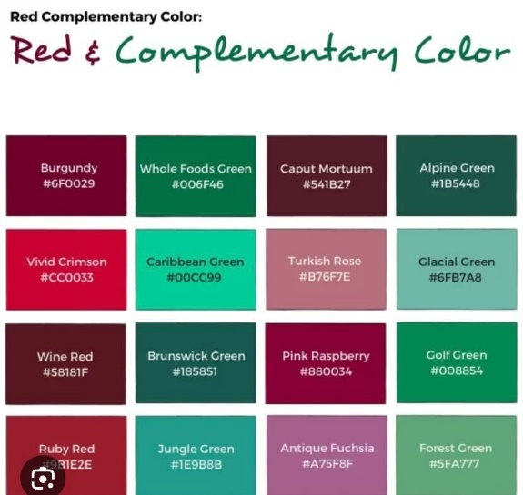

Roles and Responsibilities

All three members will be involved in the Tableau and ML aspects of the project. We will more specifically define the roles on Monday 3/18 when all members are able to meet.

The aim of our project is to uncover what properties produce good wine quality. We’ll examine relationships between the physicochemical variables with its quality ratings.